How to setup Jupyterlab to work with Github using Git Bash

This documentation was made to demonstrate how I set up JupyterLab to work with Github using Git Bash. This documentation shows the steps using Windows 10. However it will work with other systems with some minor differences.

This documentation assumes that you have created a branch in Github with MOP-CODE downloaded on your local machine with your name folder within Playground folder. If you haven’t, please follow the Github tutorial pdf posted in files in your Project Chat.

# Steps to follow to setup JupyterLab to work with Github using Git Bash

**PREREQUISITE – you should have created a branch in Github with MOP-CODE downloaded on your local machine with your name folder within Playground folder.  If you haven’t please follow the github tutorial pdf posted in files of T3 MOP data science chat group.**

**Step 1:** Install Anaconda on your system. You can refer to the video link below to see how to install and set up Anaconda on your machine. The video shows installation on Windows 10 machine.

**https://www.youtube.com/watch?v=UTqOXwAi1pE**

**Step 2**: Install Git. Here is a useful video on how to install on a Windows 10 machine

[**https://www.youtube.com/watch?v=cJTXh7g-uCM**](https://www.youtube.com/watch?v=cJTXh7g-uCM)

**Step 3:** Open Anaconda Navigator. It will be in your Start Menu.

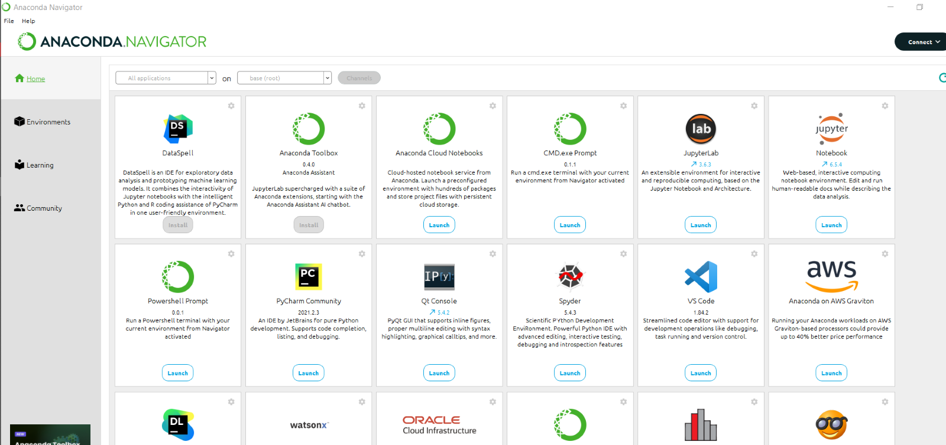

**Step 4:** Click “Launch” on Notebook (Jupyterlab) to open JupyterLab. It will open Jupyterlab in your default browser.

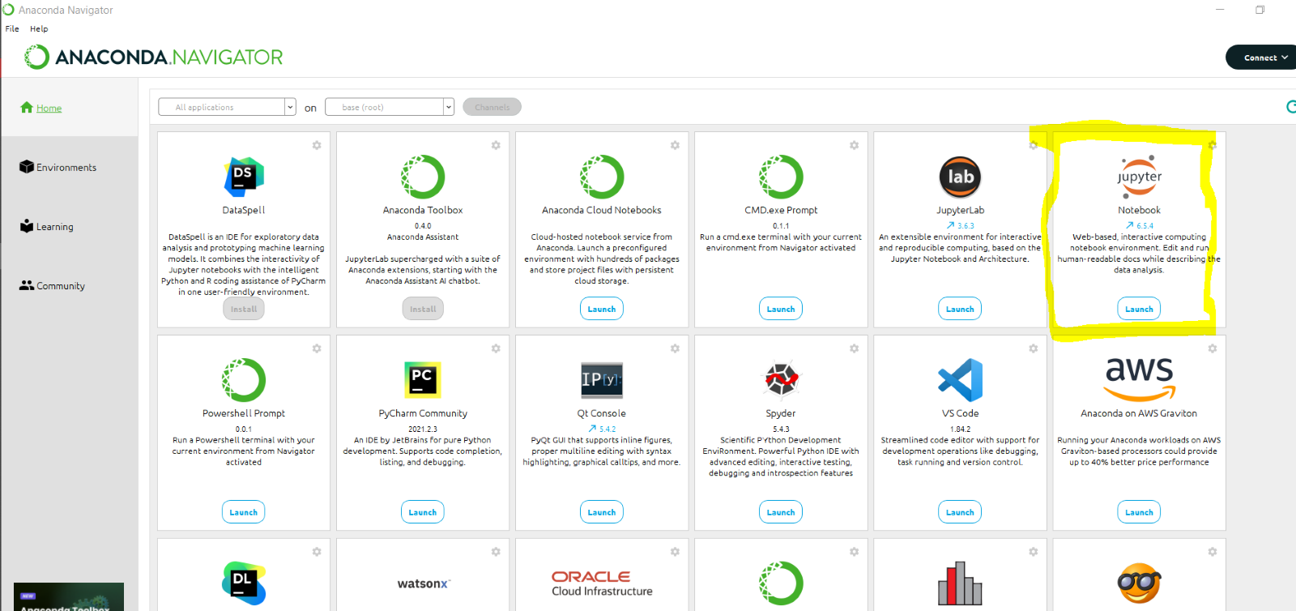

**Step 5:** Locate your Playground folder and click on your name folder (in Jupyterlab).

(if you do not know where the playground folder is located in your local machine, type “MOP-CODE” in your search bar à  right-click à”Open file Location ”. It will open the window where your Playground file is located at. )

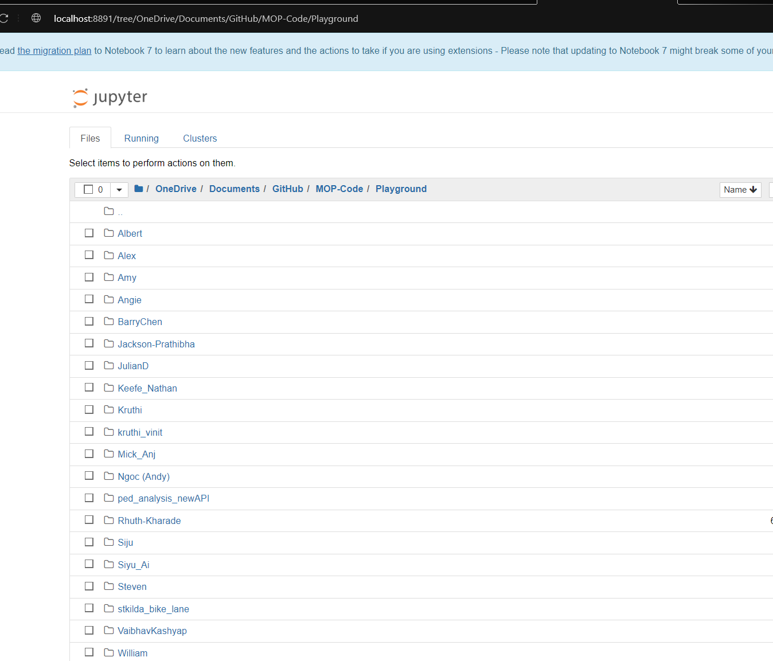

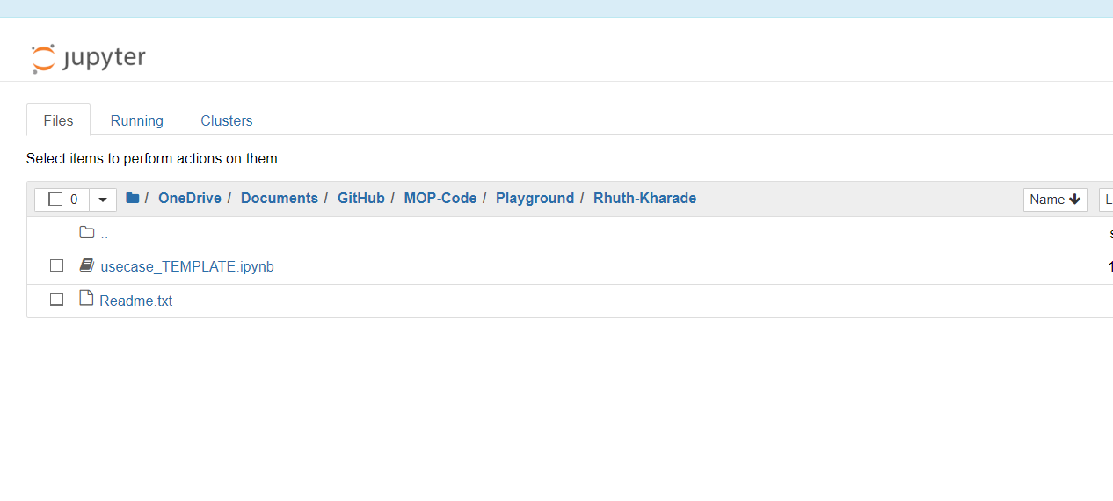

**Step 6:** Locate your playground folder in your local machine.

(if you do not know where the playground folder is located in your local machine, type “MOP-CODE” in your search bar à  right-click à”Open file Location ”. It will open the window where your Playground file is located at. )

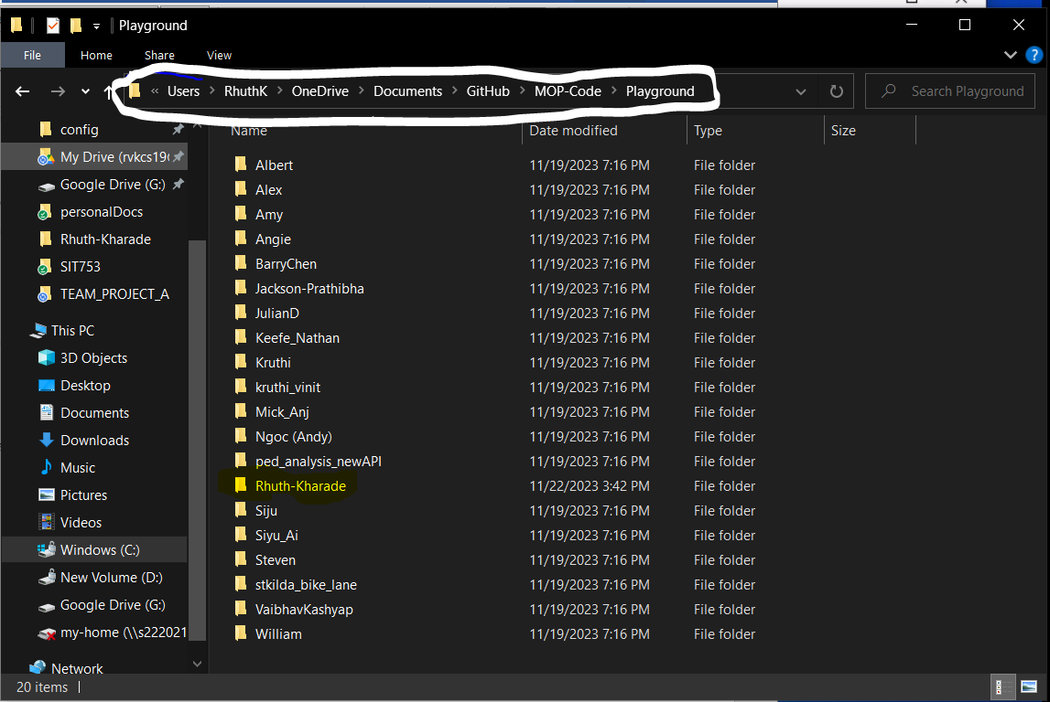

**Step 7:** Click on your own name folder within the playground and click on it. 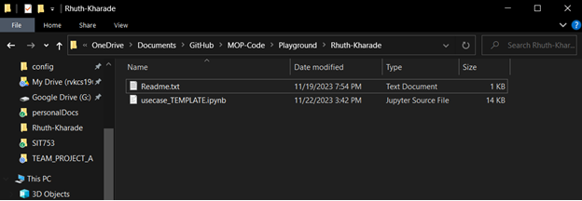

**Step 8:** Click on the path and copy it.

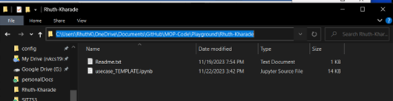

**Step 9:** Right Click on this blank area and click on “Git Bash Here’

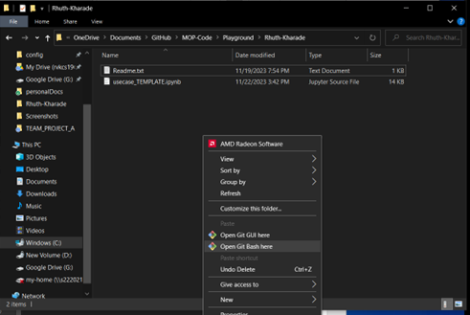

Git bash opens with the path set as the current working directory.

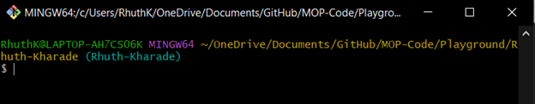

**Step 10 :** Type “git init”. It will create a hidden .git folder in your Playground folder (current working directory)

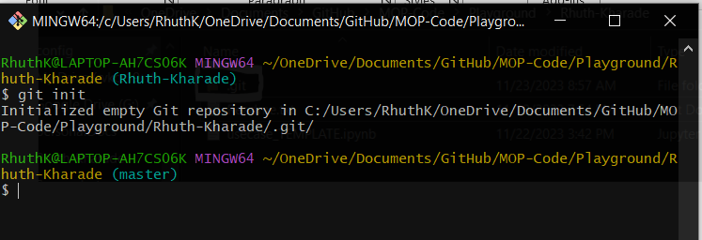

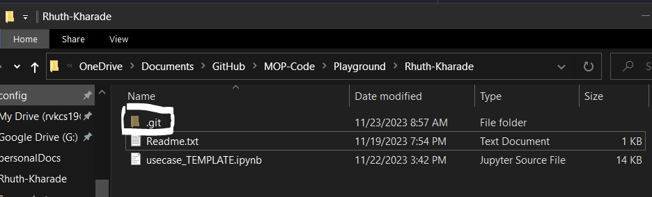

**Step 11:** Make changes in your usecase_TEMPLATE.ipynb and save your work (Ctrl + S)

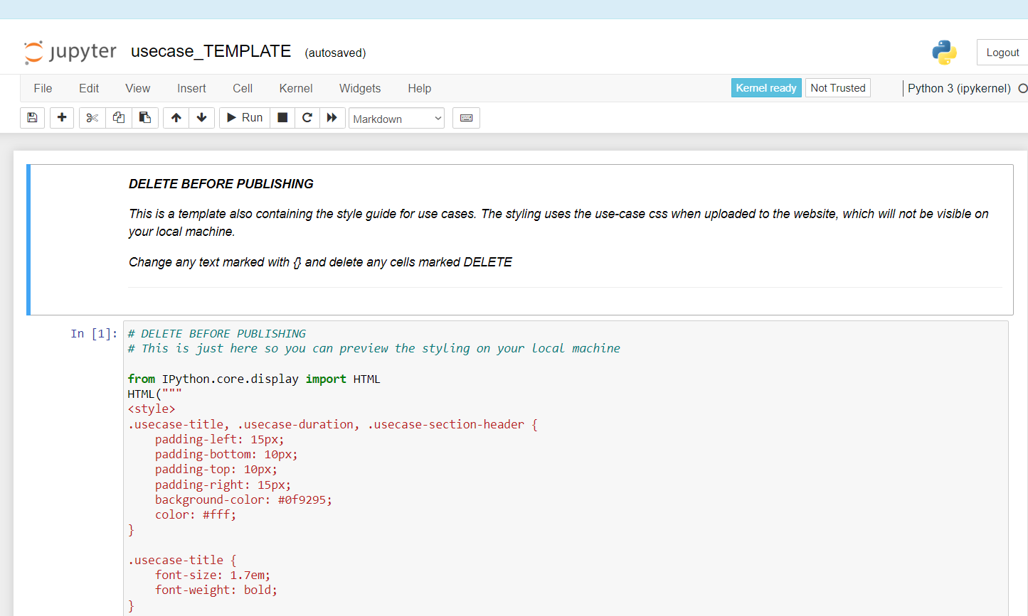

**Step 12**: Close the git bash and open the playground folder (not your name folder but the plays=ground folder itself). Right Click à Open Git Bash Here

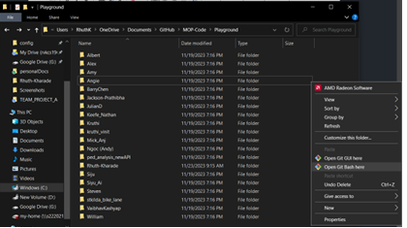

**Step 13**: Type Fetch origin in your git bash

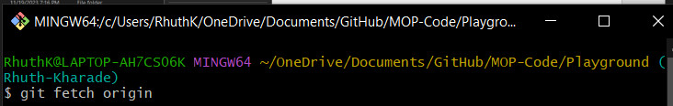

**Step 14**: Type  git add .

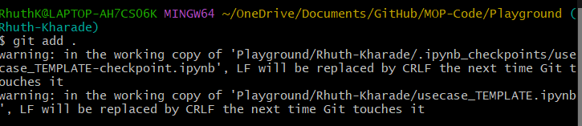

**Step 15**: Type   git commit -m ‘your message here’   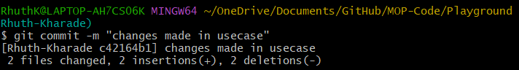

**Step 16**: Type git push to push your changes made in Jupyterlab.

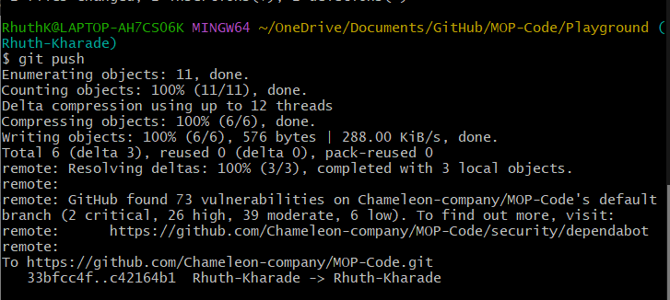

If you are working in a group then you will have to pull your friend’s changes first

To do so open git bash in your Playground folder (not name folder, playground folder) and then

Type git fetch origin and then  git pull.

Once you make new changes in your Jupyterlab, follow step 13 to 16 to push your work.

**Link to some useful Git commands**: **https://github.com/joshnh/Git-Commands**

## Author

RHUTUVARUNI KHARADE,

11/23/2023